PIAAC Log data interactions

1. Booklet & item_id order

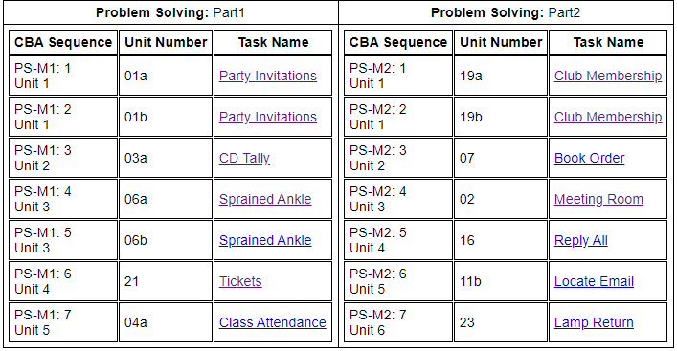

1. Event_name: “taoPIAAC”, “stimulus”

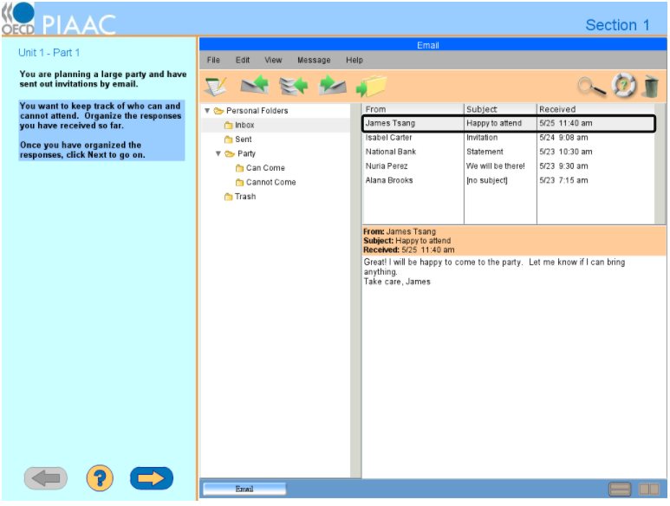

* Event in the left panel: “taoPIAAC”
* Event in the right panel: “Stimulus”

1. Interactions between logged actions (especially event_type)
2. General point

* In general, the raw log data for item u01a (see “PS_u01a.xlsx”) contain actions regarded as separate, but some actions do occur simultaneously. This is because raw log data basically record both of **core actions (what examinees really do) and ancillary actions corresponding to core actions’ details (e.g., in “DOACTION”, window shows or hides).**
* One example of ancillary actions is “DOACTION”. This action shows which system event is activated by respondent’s interaction event. This event always occurs in following other actions which examinees click in some icons or do decision, such as “TOOLBAR”, “COPY”, “PASTE”, and so on.
* **One core action may correspond to several ancillary actions**, and separated logs for those actions may be important in terms of recording but not be important in our purpose. Therefore, it is needed to integrate pair of actions into one variable as far as we don’t lose any information for analysis.
* One way to figure out interactions between core actions and ancillary actions is to investigate **‘time_stamp’ variable**. Values for ‘time_stamp’ show the time moment of actions from beginning in milli-second metric (0.001s). It leads to a fact that actions in one pair usually have the exact same value for ‘time_stamp’ or sometimes have a distance within 5 milli-seconds because of processing delay.
* Another way is to look into **response mode** in PIAAC website (<https://piaac-logdata.tba-hosting.de/index.html>). This mode provides a virtual mode to simulate how to respond to each item, **and log-information** is presented. For example, when I put a cursor on the ‘replyall’ icon in ‘TOOLBAR’, the boxed area indicates that if clicking, following actions will occur. In this case, ‘TOOLBAR’, and two ‘DOACTION’s will be logged at once.

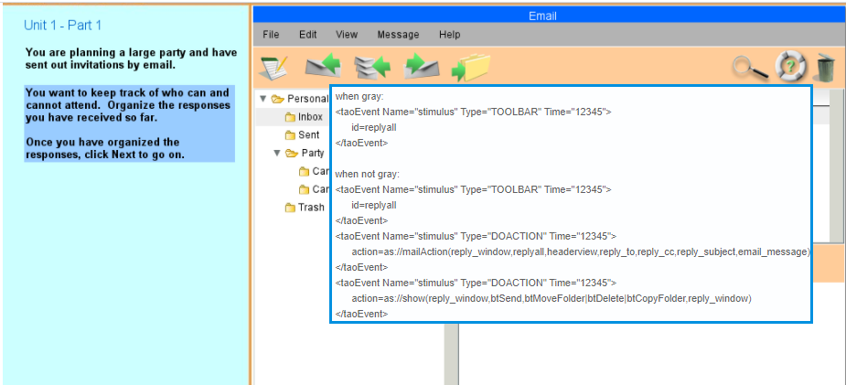

**<Specific interactions in all items>**

1. ‘MENUITEM’ & some actions (‘COPY’, ‘PASTE’, ‘MAIL_DELETED’, ‘MC_HELP_MENUITEM’, ‘SORT_MENU’)

* ‘MENU_ITEM’ & some actions happen at the same time.

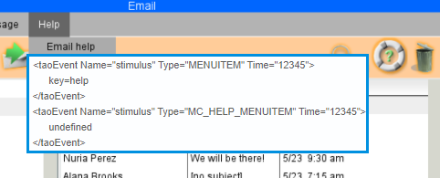

* However, other actions of MENUITEM do not record ancillary actions (e.g., Message – New)

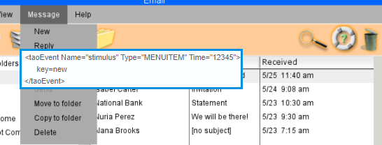

* **Integrated variable**: MENUITEM_’key’ (e.g., MENUITEM_new)
* Related items: ALL ITEMS

1. ‘BUTTON’ & some actions (‘MC_SORT’) & ‘DOACTION’

* These actions occur after clicking in some TOOLBARs or MENUITEMs to manipulate further options (e.g., SORT, newfolder).
* For example, after clicking in MENUITEM_sort,

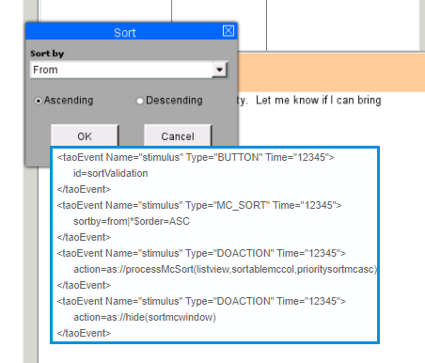

* If clicking in ‘OK’ button, ‘BUTTON’ & ‘MC_SORT’ & two ‘DOACTION’s are logged.
* In this case, **integrated variable**: ‘SORT_ok’
* If clicking in ‘Cancel’ button, ‘BUTTON’ & ‘DOCATION’ are logged.
* In this case, **integrated variable**: ‘SORT_cancel’
* There are also other types of actions similar to this SORT case (e.g., MENUITEM_deletefolder). In those other cases, integrated variables will be made in the similar manner.
* Related items: ALL ITEMS

1. KEYPRESS

* ‘KEYPRESS’: typing a key in keyboard
* It is usual that examinees press keys to make a word or sentence. So many ‘KEYPRESS’ values are logged. For example, there must be five consecutive KEYPRESS values to make a word ‘MINHO’. Therefore, it is reasonable to integrate many ‘KEYPRESS’s between other types of actions and to calculate time by subtracting the first KEYPRESS time stamp from the last KEYPRESS time stamp.
* **Integrated variable**: KEYPRESS / **event_description**: num_x_time_y (x: the number of continuous keypresses; y: the last timestamp – the first timestamp)

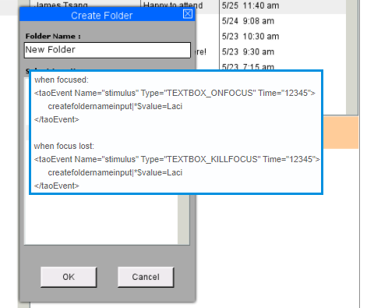

* Related items: ALL ITEMS
* OTHER INTERACTIONS WITH KEYPRESS
* Two (or three) KEYPRESSES + SHORTCUT + COPY or PASTE + DOACTION
* In this case, values of time_stamp of SHORTCUT are often smaller than Two keypresses
* Time_stamps of SHORTCUT / COPY or PASTE / DOACTION are the same.
* **Integrated variable**: SHORTCUT_copy / paste
* Related variable: u01b (Party invitation – Accommodations)

1. TOOLBAR & actions (MAIL_DELETED, MC_HELP_TOOLBAR, or ENVIRONMENT) & DOACTION

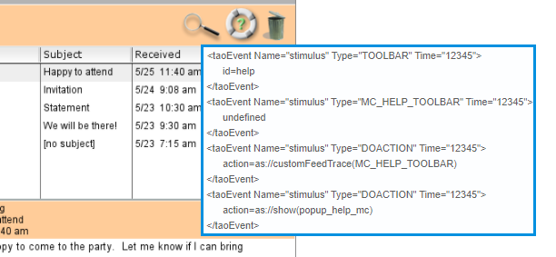

* However, other actions of TOOLBAR do not record ancillary actions (e.g., TOOLBAR-replyall)
* **Integrated variable**: TOOLBAR_id (e.g., TOOLBAR_help)
* Related items: ALL ITEMS

1. When moving to next item.

* When an examinee wants to move to next item, he or she will click in the right arrow icon at the lower left panel.

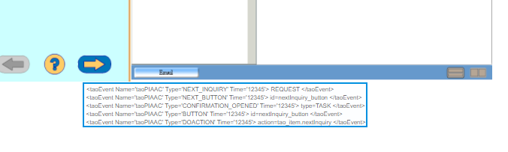

* When clicking in this icon, there are five logged actions at once as seen in above figure.
* **Integrated variable**: NEXT_INQUIRY

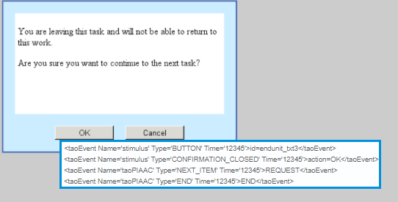

* Above screen asks whether ending the item or not.
* If clicking in OK, **integrated variable**: END
* If clicking in Cancel, **integrated variable**: END_cancel
* Related items: all items

**<Item specific interactions>**

1. MAIL_DROP & MAIL_MOVED

* ‘MAIL_DROP’: showing a mail has been dropped into a target folder
* ‘MAIL_MOVED’: showing system actions execute a moving mail event

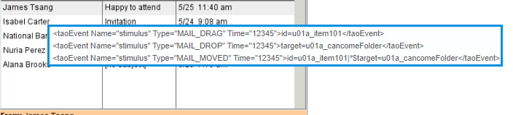

* MAIL_DROP & MAIL_MOVED happen at the same time, and it means that a mail has been moved into a target folder (e.g., cancome folder)
* **Integrated variable**: ‘MAIL_MOVED’
* Related items: PS1_1 (Party invitation – can/cannot come), PS1_2 (Party invitation – Accommodations), PS2_4 (Meeting room), PS2_5 (Reply all), and PS2_6 (Locate email)

1. Combobox in ‘taoPIAAC’ part (PS1_5 only)

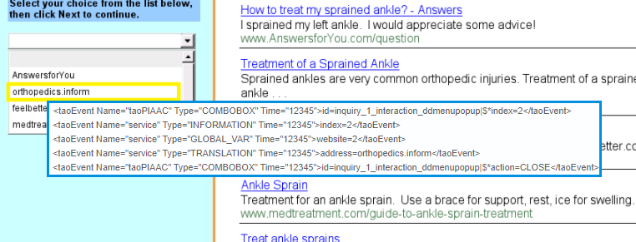

* When an examinee responds to an option among five indices (websites).
* This behavior is choosing an answer, which is the core action in this item to get score.
* **Integrated variable**: COMBOBOX / event_description: index=2 (in this case)

1. TEXTLINK & HISTORY_ADD (also BOXPRESS & HISTORY_ADD in PS1_6)

* Clicking in a website.

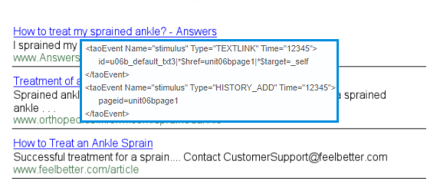

* **Integrated variable**: TEXTLINK
* Related items: PS1_5 (Sprained Ankle – Reliable/Trustworthy site), PS1_6 (tickets), PS2_3 (Book order), PS2_4 (Meeting room), PS2_5 (Reply all), and PS2_6 (Locate Email)

1. SHORTCUT (PS1_2)

* There is SHORTCUT actions for copy and paste.
* Integrated variable: SHORTCUT_copy / SHORTCUT_paste

**<Data cleaning strategy>**

* First, delete DOACTION because all DOACTIONs are ancillary actions.
* Second, delete ancillary actions for NEXT_INQUIRY, END, & END_CANCEL.

|  |
| --- |
| NEXT INQUIRY: NEXT_BUTTON / CONFIRMATION_OPENED / BUTTON (id=nextInquiry_button)  END: BUTTON (id=endtask_txt3 or id=endunit_txt3) / CONFIRMATION_CLOSED / NEXT_ITEM  END_CANCEL: BUTTON (id=endunit_txt4 OR id=endtask_txt4) / CONFIRMATION_CLOSED |

* Third, delete ancillary actions for BUTTON, TOOLBAR, & MENUITEM, and change their values in order to distinguish actions by using item_description.
* Fourth, delete item-specific ancillary actions
* Fifth, aggregate KEYPRESSes.
* The new values for BUTTON, TOOLBAR, & MENUITEM are in each excel file.